51 (1965) Nr. 18
TRACTATENBLAD
VAN HET
KONINKRIJK DER NEDERLANDEN
JAARGANG 2016 Nr. 153

A. TITEL
Verdrag inzake het vergemakkelijken van het internationale verkeer ter zee (met Bijlage);
Londen, 9 april 1965

Voor een overzicht van de verdragsgegevens, zie verdragsnummers 004167 en 013361 in de Verdragenbank.

B. TEKST1)
Tijdens haar veertigste zitting heeft de Vereenvoudigingscommissie op 8 april 2016 in overeenstemming met artikel VII, tweede lid, onderdeel a, van het Verdrag bij Resolutie FAL.12(40) wijzigingen van de Bijlage bij het Verdrag aangenomen.
De Engelse tekst van genoemde wijzigingen luidt als volgt:

Annex

Proposed amendments to the Annex to the Convention on Facilitation of International Maritime Traffic, 1965

SECTION 1
DEFINITIONS AND GENERAL PROVISIONS

A.
Definitions
For the purpose of the provisions of this annex, the following meanings shall be attributed to the terms listed:
Attempted stowaway. A person who is secreted on a ship, or in cargo which is subsequently loaded on the ship, without the consent of the shipowner or the master or any other responsible person, and who is detected on board the ship before it has departed from the port.
Cargo. Any goods, wares, merchandise, and articles of every kind whatsoever carried on a ship, other than mail, ship’s stores, ship’s spare parts, ship’s equipment, cargo transport units not carried under a contract of carriage with a shipper, crew’s effects and passengers’ accompanied baggage.
Cargo transport unit (CTU). A freight container, swap-body, vehicle, railway wagon or any other similar unit.
Clearance. Accomplishment of customs and/or other formalities necessary to:
a) Permit goods to enter home use, to be exported or to be placed under another customs procedure (so called customs clearance),
b) Permit persons to enter the territory of a State, or
c) Permit a ship to enter or depart a port within the territory of a State.
Crew’s effects. Clothing, items in everyday use and other articles, which may include currency, belonging to the crew and carried on the ship.
Crew member. Any person actually employed for duties on board during a voyage in the working or service of a ship and included in the crew list.
Cruise ship. A ship on an international voyage carrying passengers participating in a group programme and accommodated aboard, for the purpose of making scheduled temporary tourist visits at one or more different ports, and which during the voyage does not normally:
a) embark or disembark any other passengers;
b) load or discharge any cargo.
Document. Information presenting data by electronic means or by non-electronic means.
Estimated time of arrival (ETA). Time when a ship estimates it will arrive at the pilot station serving a port or, when it expects to enter a specific location in the port area, where port regulations apply.
Freight container. An article of transport equipment that is of a permanent character and accordingly strong enough to be suitable for repeated use; specially designed to facilitate the transport of goods, by one or other modes of transport, without intermediate reloading: designed to be secured and/or readily handled, having fittings for these purposes, and approved in accordance with the International Convention for Safe Containers (CSC), 1972, as amended. The term “freight container“ includes neither vehicle nor packaging; however a freight container that is carried on a chassis is included.
ISPS Code. The “International Ship and Port Facility Security (ISPS) Code” adopted on 12 December 2002 by resolution 2 of the Conference of Contracting Governments to the International Convention for the Safety of Life at Sea, 1974 (SOLAS), as may be amended by the Organization.
Manifest. Document recapitulating the various data from bills of lading and other transport documents issued for the carriage of goods on board ships.
Master. The person having command of a ship.
Passenger in transit. A passenger who arrives by ship from a foreign country for the purpose of continuing his/her journey by ship or some other means of transport to a foreign country.
Passengers’ accompanied baggage. Property, which may include currency, carried for a passenger on the same ship as the passenger, whether in his/her personal possession or not, so long as it is not carried under a contract of carriage of goods or other similar agreement.
Port. Any port, terminal, offshore terminal, ship and repair yard or roadstead which is normally used for the loading, unloading, repair and anchoring of ships, or any other place at which a ship can call.
Postal items. Correspondence and other objects tendered to be carried by a ship for carriage by postal administrations and intended for delivery to postal administrations in the ship’s ports of call.
Public authorities. The agencies or officials in a State responsible for the application and enforcement of the laws and regulations of that State which relate to any aspect of the Standards and Recommended Practices contained in this annex.
Release. Action taken by customs authorities to permit goods undergoing clearance to be placed at the disposal of the persons concerned.
Security measures. Measures developed and implemented in accordance with international agreements to improve security on board ships, in port areas, facilities and of goods moving in the international supply chain to detect and prevent unlawful acts1) .
Ship Agent: The party representing the ship’s owner and/or charterer (the Principal) in port. If so instructed, the agent is responsible to the Principal for arranging, together with the port, a berth, all relevant port and husbandry services, tending to the requirements of the Master and crew, clearing the vessel with the port and other authorities (including preparation and submission of appropriate documentation) along with releasing or receiving cargo on behalf of the Principal.
Single Window. A facility that allows submission of standardized information covered by the Convention to a single entry point.
Shipowner. One who owns or operates a ship, whether a person, a corporation or other legal entity, and any person other than the ship agent acting on behalf of the owner or operator.
Ship’s documents. Certificates and other documents which must be made available by a ship’s master in order to demonstrate the vessel’s compliance with international or national regulations.
Ship’s equipment. Articles, other than ship’s spare parts, on board a ship for use thereon, which are removable but not of a consumable nature, including accessories such as lifeboats, life-saving devices, furniture, ship’s apparel and similar items.
Ship’s spare parts. Articles of a repair or replacement nature for incorporation into the ship in which they are carried.
Ship’s stores. Goods for use in the ship, including consumable goods, goods carried for sale to passengers and crew members, fuel and lubricants, but excluding ship’s equipment and ship’s spare parts.
Shipper. The party named on the bill of lading or waybill as shipper and/or who concludes a contract of carriage (or in whose name or on whose behalf a contract of carriage has been concluded) with a carrier. Also known as the sender.
Shore leave. Permission for a crew member to be ashore during the ship’s stay in port within such geographical or time limits, if any, as may be decided by the public authorities.
Stowaway. A person who is secreted on a ship, or in cargo which is subsequently loaded on the ship, without the consent of the shipowner or the master or any other responsible person and who is detected on board the ship after it has departed from a port, or in the cargo while unloading it in the port of arrival, and is reported as a stowaway by the master to the appropriate authorities.
Temporary admission. The customs procedure under which certain goods can be brought into a customs territory conditionally relieved, totally or partially, from payment of import duties and taxes and without application of import prohibitions or restrictions of economic character; such goods must be imported for a specific purpose and must be intended for re-exportation within a specified period and without having undergone any change except normal depreciation owing to the use made of them.
Time of arrival. Time when a ship first comes to rest, whether at anchor or at a dock, in a port.
Transport document. Information evidencing a contract of carriage between a shipowner and a shipper, such as a sea waybill, a bill of lading or a multi-modal transport document.

B.
General provisions
In conjunction with paragraph 2 of article V of the Convention, the provisions of this annex shall not preclude public authorities from taking such appropriate measures, including calling for further information, as may be necessary in cases of suspected fraud, or to deal with special problems constituting a grave danger to public order (ordre public), public security or public health, such as unlawful acts against the safety of maritime traffic and illicit trafficking in narcotic drugs and psychotropic substances, or to prevent the introduction or spread of disease or pests affecting animals or plants.
1.1 Standard. Public authorities shall in all cases require only essential information to be furnished, and shall keep the number of items to a minimum.
1.1.1 Not in use
1.2 Recommended Practice. Notwithstanding the fact that documents for certain purposes may be separately prescribed and required in this annex, public authorities, bearing in mind the interests of those who are required to complete the documents as well as the purposes for which they are to be used, should provide for any two or more such documents that are to be submitted by the same party to be combined into one in any case in which this is practicable and in which an appreciable degree of facilitation would result.
1.3 Recommended Practice. Measures and procedures imposed by Contracting Governments for the purposes of security or preventing the trafficking of narcotics should be efficient. Such measures and procedures (e.g. risk management and cross-checking of information) should be implemented in such a manner as to cause a minimum of interference with, and to prevent unnecessary delays to, ships and persons or property on board.

C.
Systems for the electronic exchange of information
1.3bis Standard. Public authorities shall take all necessary measures for the establishment of systems for the electronic exchange of information by [Insert: Date of Adoption + 3 years].
1.3ter Standard. Public authorities, when introducing systems for the electronic exchange of information to assist clearance processes, shall provide shipowners and other parties concerned with the necessary information about the systems requirements and give an adequate period of transition before the use of the systems are made mandatory. A period of no less than 12 months for transition to the mandatory use of the systems shall be provided from the date of the introduction of such systems.
1.3quart Recommended Practice. Public authorities should, for a transitional period, allow for the submission of required information for clearance processes in both electronic and paper form.
1.3quin Recommended Practice. Contracting Governments should encourage public authorities to introduce arrangements to enable the submission of all the information required by public authorities in connection with the arrival, stay and departure of ships, persons and cargo, avoiding duplication, to a “Single Window”.
Consideration should also be given to such a Single Window serving as the mechanism through which the public authorities communicate decisions and other information covered by this Convention.
1.4 Not in use
1.5 Not in use
1.6 Standard. Public authorities, when introducing systems for the electronic exchange of information for clearance processes, shall limit the information they require from shipowners and other parties concerned to that required by the FAL Convention.
1.6bis Standard. When introducing systems for the electronic exchange of information required by public authorities for the arrival, stay and departure of the ship, persons and cargo to facilitate clearance processes, Contracting Governments shall encourage public authorities and other parties concerned (shipowners, handling companies, seaports, and/or cargo agents, etc.) to exchange data in conformity with the relevant UN Standards, including UN Electronic Data Interchange for Administration, Commerce and Transport (UN/EDIFACT) Standards, or other internationally agreed Standards, such as the XML Standard.
1.6ter Recommended Practice. When introducing new electronic message formats, public authorities should continue to allow for the usage of existing electronic message formats in agreement with the parties concerned.
1.7 Recommended Practice. When planning for, introducing or modifying systems for the electronic exchange of information for clearance processes, public authorities should:
a) afford all interested parties, from the outset, the opportunity for consultation;
b) evaluate existing procedures and eliminate those which are unnecessary;
c) determine those procedures which are to be computerized;
d) use United Nations (UN) Recommendations, WCO Information Packages and relevant ISO Standards to the maximum extent practicable;
e) adapt these systems for multimodal applications;
f) take appropriate steps to minimize the cost of implementing these systems to operators and other private parties; and
g) give attention to the desirability of obtaining compatibility with other relevant information systems.
1.7.1 Recommended Practice. Contracting Governments should encourage public authorities and other parties concerned to cooperate or participate directly in the development of electronic systems using internationally agreed Standards with a view to enhancing the exchange of information relating to the arrival, stay and departure of ships, persons and cargo and assuring inter-operability between the systems of public authorities and other parties concerned.
1.8 Not in use
1.8.1 Not in use

D.
Illicit drug trafficking
1.9 Recommended Practice. Public authorities should seek to establish cooperation arrangements with shipowners and other parties concerned to improve their ability to combat drug smuggling, while providing enhanced facilitation. Such arrangements could be based on the Customs Cooperation Council2) Memoranda of Understanding and the associated guidelines.
1.10 Standard. Where, as part of cooperation arrangements, public authorities, shipowners, and other parties concerned are provided access to sensitive commercial and other information, the information shall be treated confidentially.

E.
Control techniques
1.11 Standard. Public authorities shall use risk management to enhance their border control procedures related to:
• the release/clearance of cargo;
• security requirements; and
• their ability to target smuggling,
thereby facilitating the legitimate circulation of persons and goods.

SECTION 2
ARRIVAL, STAY AND DEPARTURE OF THE SHIP
This section contains the provisions concerning the formalities required of shipowners by the public authorities on the arrival, stay and departure of the ship and shall not be read so as to preclude a requirement for the presentation, for inspection by the appropriate authorities, of certificates and other documents made available by the ship pertaining to its registry, measurement, safety, manning and other related matters.3)

A.
General
2.1 Standard. Public authorities shall not require for their retention, on arrival or departure of ships to which the Convention applies, any documents other than those covered by the present section.
The documents in question are:
• General Declaration
• Cargo Declaration
• Ship’s Stores Declaration
• Crew’s Effects Declaration
• Crew List
• Passenger List
Dangerous Goods Manifest
• The document required under the Universal Postal Convention for mail
• Maritime Declaration of Health
• Security-related information as required under SOLAS regulation XI-2/9.2.2
• Advance electronic cargo information for customs risk assessment purposes
• Advanced Notification Form for Waste Delivery to Port Reception Facilities, when communicated to the Organization.
2.1.1 Standard. Contracting Governments shall not require consular formalities, charges or fees in connection with documents for the clearance of ships, including the electronic submission of documents.
2.1.2 Standard.Public authorities shall develop procedures for the lodgement of pre-arrival and pre-departure information in order to facilitate the processing of such information for the expedited subsequent release/clearance of cargo and persons.
2.1.3 Recommended Practice. National legislation should specify the conditions for the lodgement of pre-arrival and pre-departure information. With regard to the point in time of transmission of the pre-arrival information, it should not normally be set before the moment the ship has left the country of departure. However, national legislation could, in addition to the basic rule, also specify the exceptions from this principle where required, e.g. for voyages of short duration.
2.1.3bis Recommended Practice. Public authorities should, for the submission of advance electronic cargo information for customs risk assessment purposes, take into account the time limits specified in the WCO SAFE Framework of Standards.
2.1.4 Recommended Practice. Public authorities should not require the lodgement of a separate General Declaration, Cargo Declaration, Crew List, Passenger List and Dangerous Goods Manifest if the data elements contained in these documents are included in the pre- arrival or pre-departure information or in the ship’s manifest.
2.1.5 Standard. Public authorities shall reuse the pre-arrival and pre-departure information in subsequent procedures where such data is required.

B.
Contents and purpose of documents
2.2 Standard. The General Declaration shall be the basic document on arrival and departure providing data required by public authorities relating to the ship.
2.2.1 Recommended Practice. The same form of General Declaration should be accepted for both the arrival and the departure of the ship.
2.2.2 Recommended Practice. In the General Declaration, public authorities should not require more than the following data:
• name, type and IMO number of ship
• call sign
• flag State of ship
• voyage number
• particulars regarding registry
• particulars regarding tonnage
• name of master
• name and contact details of ship’s agent
• brief description of the cargo
• number of crew
• number of passengers
• brief particulars of voyage
• date and time of arrival/departure
• port of arrival/departure
• the ship’s requirements in terms of waste and residue reception facilities
• last port of call/next port of call.
2.2.3 Standard. Public authorities shall accept that the General Declaration is either dated and signed by the master, the ship’s agent or some other person duly authorized by the master, or authenticated in a manner acceptable to the public authority concerned.
2.3 Standard. The Cargo Declaration shall be the basic document on arrival and departure providing data required by public authorities relating to the cargo. However, particulars of any dangerous cargo may also be required to be furnished separately.
2.3.1 Recommended Practice. In the Cargo Declaration, public authorities should not require more than the following data:
a) on arrival
• name and IMO number of ship
• flag State of ship
• name of master
• voyage number
• port of loading
• port where report is made
• freight container identification, where appropriate; marks and numbers; number and kind of packages; quantity and description of the goods or, if available, the HS Code4)
• transport document numbers for cargo to be discharged at the port in question
• ports at which cargo remaining on board will be discharged
• original ports of shipment in respect of goods shipped under multimodal transport documents or through bills of lading.
b) on departure
• name and IMO number of ship
• flag State of ship
• name of master
• voyage number
• port of discharge
• in respect of goods loaded at the port in question: freight container identification, where appropriate; marks and numbers; number and kind of packages; quantity and description of the goods or, if available, the HS Code
• transport document numbers for cargo loaded at the port in question.
2.3.2 Standard. In respect of cargo remaining on board, public authorities shall require only brief details of the minimum essential items of information to be furnished.
2.3.3 Standard. Public authorities shall accept that the Cargo Declaration is either dated and signed by the master, the shipowner issuing the transport document, the ship’s agent or some other person duly authorized by the master, or authenticated in a manner acceptable to the public authority concerned.
2.3.4 Standard. Public authorities shall accept in place of the Cargo Declaration a copy of the ship’s manifest provided it contains at least the information required in accordance with Recommended Practice 2.3.1 and Standard 2.3.2 and is signed or authenticated, and dated, in accordance with Standard 2.3.3.
2.3.4.1 Recommended Practice. As an alternative to Standard 2.3.4, public authorities may accept a copy of the transport document signed or authenticated in accordance with Standard 2.3.3, or certified as a true copy, if the nature and quantity of cargo make this practicable and provided that any data required and identified in accordance with Recommended Practice 2.3.1 and Standard 2.3.2 which does not appear in such documents is also furnished elsewhere and duly certified.
2.3.5 Standard. Public authorities shall allow unmanifested parcels in possession of the master to be omitted from the Cargo Declaration provided that particulars of these parcels are furnished separately.
2.4 Standard. The Ship’s Stores Declaration shall be the basic document on arrival and departure providing information required by public authorities relating to ship’s stores.
2.4.1 Standard. Public authorities shall accept that the Ship’s Stores Declaration is either dated and signed by the master or by some other ship’s officer duly authorized by the master and having personal knowledge of the facts regarding the ship’s stores, or authenticated in a manner acceptable to the public authority concerned.
2.5 Standard. The Crew’s Effects Declaration shall be the basic document providing information required by public authorities relating to crew’s effects. It shall not be required on departure.
2.5.1 Standard. Public authorities shall accept that the Crew’s Effects Declaration is either dated and signed by the master or by some other ship’s officer duly authorized by the master, or authenticated in a manner acceptable to the public authority concerned. For the purpose of onboard verification, the public authorities may also require each crew member to sign or verify in a manner acceptable to the public authorities the declaration relating to his/her personal effects.
2.5.2 Recommended Practice. Public authorities should normally require particulars of only those crew’s effects which would not qualify for relief from customs duties and taxes or which are subject to prohibitions or restrictions.
2.6 Standard. The Crew List shall be the basic document required by public authorities containing data relating to the number and composition of the crew on the arrival and departure of a ship.
2.6.1 Standard. In the Crew List, public authorities shall not require more than the following data:
• name and IMO number of ship
• flag State of ship
• call sign
• voyage number
• family name
• given names
• nationality
• rank or rating
• gender
• date and place of birth
• nature and number of identity document
• issuing State of identity document
• expiry date of identity document
• port and date of arrival/ departure
• last port of call.
2.6.2 Standard. Public authorities shall accept that the Crew List is either dated and signed by the master or by some other ship’s officer duly authorized by the master, or authenticated in a manner acceptable to the public authority concerned.
2.6.3 Not in use.
2.6.4 Recommended Practice. In cases where a ship, serving in a scheduled programme, calls again at the same port at least once within 14 days and where minor changes in the crew have taken place, public authorities should not normally require a new, full Crew List to be submitted but should accept the existing Crew List with the changes indicated.
2.7 Standard. The Passenger List shall be the basic document required by public authorities containing the data relating to passengers on the arrival and departure of a ship.
2.7.1 Not in use.
2.7.2 Recommended Practice. Public authorities should not require embarkation or disembarkation cards in addition to Passenger Lists in respect of passengers whose names appear on those Lists. However, where public authorities have special problems constituting a grave danger to public health, a person on an international voyage may on arrival be required to give a destination address in writing.
2.7.3 Standard. In the Passenger List, public authorities shall not require more than the following data:
• name and IMO number of ship
• call sign
• flag State of ship
• voyage number
• family name
• given names
• nationality
• date of birth
• place of birth
• gender
• type of identity or travel document
• serial number of identity or travel document
• issuing State of identity or travel document
• expiry date of identity or travel document
• port of embarkation
• visa number, if appropriate
• port of disembarkation
• port and date of arrival/departure of the ship
• transit passenger or not.
2.7.4 Recommended Practice. A list compiled by the shipowners for their own use should be accepted in place of the Passenger List, provided it contains at least the information required in accordance with Standard 2.7.3 and is dated and signed or authenticated in accordance with Standard 2.7.5.
2.7.5 Standard. Public authorities shall accept that the Passenger List is either dated and signed by the master, the ship’s agent or some other person duly authorized by the master, or authenticated in a manner acceptable to the public authority concerned.
2.8 Standard. The Dangerous Goods Manifest shall be the basic document providing public authorities with the information regarding dangerous goods.
[2.8.1 Standard. In the Dangerous Goods Manifest public authorities shall not require more than the following information:
• name of ship
• call sign
• IMO number
• flag State of ship
• master’s name
• voyage number
• port of loading
• port of discharge
• shipping agent
• [transport document numbers for dangerous goods to be discharged at the port in question]
• marks and numbers
– freight container ID No(s).
– vehicle Reg. No(s).
• number and kind of packages
• proper shipping name
• class
• UN Number
• packing group
• subsidiary risk(s)
• flashpoint (in oC, c.c.)
• marine pollutant
• mass (kg) – gross/net
• EmS
• stowage position on board
• additional information.]
2.9 Standard. Public authorities shall not require on arrival or departure of the ship any written declaration in respect of postal items other than that prescribed in the Universal Postal Convention, provided the latter is actually produced. In the absence of such a document, the postal objects (number and weight) must be shown in the Cargo Declaration.
2.10 Standard. The Maritime Declaration of Health shall be the basic document containing the data required by port health authorities relating to the state of health on board a ship during the voyage and on arrival at a port.

C.
Documents on arrival
2.11 Standard. Until the expiration of the transitional period referred to in Standard 1.3ter, public authorities shall in respect of a ship’s arrival in port not require more than:
• 5 copies of the General Declaration
• 4 copies of the Cargo Declaration
• 4 copies of the Ship’s Stores Declaration
• 2 copies of the Crew’s Effects Declaration
• 4 copies of the Crew List
• 4 copies of the Passenger List
• 1 copy of the Dangerous Goods Manifest
• 1 copy of the Maritime Declaration of Health
• 1 copy of the security-related information as required under SOLAS regulation XI-2/9.2.2
• 1 copy of the Advanced Notification Form for Waste Delivery to Port Reception Facilities when communicated to the Organization.
Upon expiration of the transitional period referred to in Standard 1.3ter, paper copies shall not be required except in case of force majeure where means of electronic transmission are unavailable.

D.
Documents on departure
2.12 Standard. Until the expiration of the transitional period referred to in Standard 1.3ter, public authorities shall in respect of a ship’s departure from port not require more than:
• 5 copies of the General Declaration
• 4 copies of the Cargo Declaration
• 3 copies of the Ship’s Stores Declaration
• 2 copies of the Crew List
• 2 copies of the Passenger List
• 1 copy of the Dangerous Goods Manifest.
Upon expiration of the transitional period, paper copies shall not be required except in case of force majeure where means of electronic transmission are unavailable.
2.12.1 Standard. A new Cargo Declaration shall not be required on departure from a port in respect of cargo which has been the subject of a declaration on arrival in that port and which has remained on board.
2.12.2 Recommended Practice. A separate Ship’s Stores Declaration on departure should not be required in respect of ship’s stores which have been the subject of a declaration on arrival, nor in respect of stores shipped in the port and covered by another customs document presented for the purpose in that port.
2.12.3 Standard. Where public authorities require information about the crew of a ship on its departure from the port, one of the copies of the Crew List presented on arrival at the port shall be accepted on departure, provided it is signed again by the master or an officer duly authorized by him/her, and endorsed or authenticated in a manner acceptable to the public authority concerned, to indicate any change in the number or composition of the crew at the time of the ship’s departure or to indicate that no such change has occurred during the ship’s stay in the port.
2.13 Not in use.

E.
Consecutive calls at two or more ports in the same State
2.14 Standard. Taking into account the procedures carried out on the arrival of a ship at the first port of call in the territory of a State, shipowners shall only be obligated to submit required information once to the public authorities of a State. The formalities and documents required by the public authorities at any subsequent port of call in that country visited without intermediate call at a port in another country shall be kept to a minimum.

F.
Completion of documents
2.15 Recommended Practice. Public authorities should as far as possible accept the documents provided for in this annex, except as regards Standard 3.7, irrespective of the language in which the required data is furnished thereon, provided that they may require a written or oral translation into one of the official languages of their country or of the Organization when they deem it necessary.
2.16 Standard. If public authorities require documents in paper form, they shall accept documents conveyed by any legible and understandable medium, including documents handwritten in ink or indelible pencil or produced by the use of information technology.
2.16.1 Standard. Public authorities shall accept a signature, when required, in handwriting, in facsimile, perforated, stamped, in symbols, or made by any other mechanical or electronic means, if such acceptance is not inconsistent with national laws. The authentication of information submitted on non-paper media shall be in a manner that is acceptable to the public authority concerned and which facilitates the electronic submission of the information by the parties concerned irrespective of their residence.
2.17 Standard. Public authorities of the country of any intended port of arrival, discharge, or transit shall not require any document relating to the ship, its cargo, stores, passengers or crew, as mentioned in this section, to be legalized, verified, authenticated, or previously dealt with by any of their representatives abroad. This shall not be deemed to preclude a requirement for the presentation of a passport or other identity document of a passenger or crew member for visa or similar purposes.

G.
Errors and amendments in documentation and penalties therefore
2.18 Standard. Public authorities shall, without delaying the ship, allow correction of errors a document provided for in this annex which they are satisfied are inadvertent, not of a serious nature, not due to recurrent carelessness and not made with intent to violate laws or regulations, on the condition that these errors are discovered before the document is fully checked and the corrections can be effected without delay.
2.19 Standard. If errors are found in the data transmitted as provided for in appendix 1 of this annex, which have been signed by or on behalf of a shipowner or master, or otherwise authenticated, no penalties shall be imposed until an opportunity has been given to satisfy the public authorities that the errors were inadvertent, not of a serious nature, not due to recurrent carelessness and not made with intent to violate the laws or regulations of the port State.
2.19bis Standard. Public authorities shall allow for amendments to information already submitted in accordance with applicable laws and regulations.

H.
Special measures of facilitation for ships calling at ports in order to put ashore sick or injured crew members, passengers, persons rescued at sea or other persons for emergency medical treatment
2.20 Standard. Public authorities shall seek the cooperation of shipowners to ensure that, when ships intend to call at ports for the sole purpose of putting ashore sick or injured crew members, passengers, persons rescued at sea, or other persons for emergency medical treatment, the master shall give the public authorities as much notice as possible of that intention, with the fullest possible details of the sickness or injury and of the identity of the persons.
2.21 Standard. Public authorities shall, by the fastest channels available, inform the master, before the arrival of the ship, of the documentation and the procedures necessary to put the sick or injured persons ashore expeditiously and to clear the ship without delay.
2.22 Standard. With regard to ships calling at ports for this purpose and intending to leave again immediately, public authorities shall give priority in berthing if the state of the sick person or the sea conditions do not allow a safe disembarkation in the roads or harbour approaches.
2.23 Standard. With regard to ships calling at ports for this purpose and intending to leave again immediately, public authorities shall not require the documents mentioned in Standard 2.1 with the exception of the Maritime Declaration of Health, and, if it is indispensable, the General Declaration. Public authorities shall in such situations waive the time limits for the submission of the documents.
2.24 Standard. Where public authorities require the General Declaration, this document shall not contain more data than those mentioned in Recommended Practice 2.2.2 and, wherever possible, shall contain less.
2.25 Standard. Where the public authorities apply control measures related to the arrival of a ship prior to sick or injured persons being put ashore, emergency medical treatment and measures for the protection of public health shall take precedence over these control measures.
2.26 Standard. Where guarantees or undertakings are required in respect of costs of treatment or eventual removal or repatriation of the persons concerned, emergency medical treatment shall not be withheld or delayed while these guarantees or undertakings are being obtained.
2.27 Standard. Emergency medical treatment and measures for the protection of public health shall take precedence over any control measures which public authorities may apply to sick or injured persons being put ashore.

SECTION 3
ARRIVAL AND DEPARTURE OF PERSONS
This section contains the provisions concerning the formalities required by public authorities from crew and passengers on the arrival or departure of a ship.

A.
Arrival and departure requirements and procedures
3.1 Standard. A valid passport shall be the basic document providing public authorities with information relating to the individual passenger on arrival or departure of a ship.
3.1.1 Recommended Practice. Contracting Governments should as far as possible agree, by bilateral or multilateral agreements, to accept official documents of identity in lieu of passports.
3.2 Standard. Public authorities shall make arrangements whereby passports, or official documents of identity accepted in their place, from ship’s passengers need be inspected by the immigration authorities only once at the time of arrival and once at the time of departure. In addition, these passports or official documents of identity may be required to be produced for the purpose of verification or identification in connection with customs and other formalities on arrival and departure.
3.3 Standard. After individual presentation of passports or official documents of identity accepted in their place, public authorities shall hand back such documents immediately after examination rather than withholding them for the purpose of obtaining additional control, unless there is some obstacle to the admission of a passenger to the territory.
3.3.1 Standard. Each Contracting Government shall ensure that the public authorities seize fraudulent, falsified or counterfeit travel documents of inadmissible persons. Such documents shall be removed from circulation and returned to the appropriate authorities when practicable. In place of a seized document, a covering letter5) shall be issued by the removing State and attached to it will be a photocopy of the forged travel documents, if available, as well as any important information. The covering letter and its attachment shall be handed over to the operator responsible for the removal of the inadmissible person. It will serve to give information to the authorities at the transit and/or the original point of embarkation.
3.3.2 Standard. Contracting Governments shall accept for examination a person being returned from his/her point of disembarkation after having been found inadmissible if this person had embarked in their territory. Contracting Governments shall not return such a person to the country where he or she was earlier found to be inadmissible.
3.3.3 Standard. Before passengers and crew are accepted for examination as to their admissibility into the State, responsibility for their custody and care shall remain with the shipowner.
3.3.4 Recommended Practice. After acceptance of passengers and crew for examination, whether conditional or unconditional and if the persons concerned are under the physical control of the public authorities, the public authorities should be responsible for their custody and care until they are admitted for entry or are found to be inadmissible.
3.3.5 Standard. The obligation of a shipowner to transport any person away from the territory of a State shall terminate from the moment such a person has been definitely admitted into that State.
3.3.6 Standard. Where a person is found to be inadmissible, the public authorities shall, without unreasonable delay, inform the shipowner and consult the shipowner regarding the arrangements for removal. The shipowner is responsible for the costs of stay and removal of an inadmissible person and, in the case where the person is transferred back to the custody of the shipowner, the shipowner shall be responsible for effecting his/her prompt removal to:
• the country of embarkation; or
• to any other place where the person is admissible.
3.3.7 Standard. Contracting Governments and shipowners shall cooperate, where practicable, to establish the validity and authenticity of passports and visas.
3.4 Recommended Practice. Public authorities should not require from embarking or disembarking passengers, or from shipowners on their behalf, any information in writing supplementary to or repeating that already presented in their passports or official documents of identity, other than as necessary to complete any documents provided for in this annex.
3.5 Recommended Practice. Public authorities which require written supplementary information, other than as necessary to complete any documents provided for in this annex, from embarking or disembarking passengers should limit requirements for further identification of passengers to the items set forth in Recommended Practice 3.6 (embarkation/disembarkation card). Public authorities should accept the embarkation/disembarkation card when completed by the passenger and should not require that it be completed or checked by the shipowner. Legible handwritten script should be accepted on the card, except where the form specifies block lettering. One copy only of the embarkation/disembarkation card, which may include one or more simultaneously prepared carbon copies, should be required from each passenger.
3.6 Recommended Practice. In the embarkation/disembarkation card, public authorities should not require more than the following information:
• family name
• given names
• nationality
• number and expiry date of passport or other official identity document
• date of birth
• place of birth
• occupation
• port of embarkation/disembarkation
• gender
• destination address
• signature.
3.7 Standard. In cases where evidence of protection against yellow fever is required from persons on board a ship, public authorities shall accept the International Certificate of Vaccination or Re-Vaccination in the forms provided for in the International Health Regulations.
3.8 Recommended Practice. Medical examination of persons on board or of persons disembarking from ships should normally be limited to those persons arriving from an area infected with quarantinable diseases within the incubation period of the disease concerned (as stated in the International Health Regulations). Additional medical examination may, however, be required in accordance with the International Health Regulations.
3.9 Recommended Practice. Public authorities should normally perform customs inspections of inbound passengers’ accompanied baggage on a sampling or selective basis. Written declarations in respect of passengers’ accompanied baggage should be dispensed with as far as possible.
3.9.1 Recommended Practice. Public authorities should, wherever possible, waive inspections of accompanied baggage of departing passengers, with due regard to the possible need to impose appropriate security measures preferably by automated means to facilitate review.
3.9.2 Recommended Practice. Where inspection of accompanied baggage of departing passengers cannot be waived completely, such inspection should normally be performed on a sampling or selective basis.
3.10 Standard. A passport or an identity document issued in accordance with relevant ILO Conventions, or else a valid and duly recognized seafarer’s identity document, shall be the basic document providing public authorities with information relating to the individual member of the crew on arrival or departure of a ship.
3.10.1 Standard. In the seafarer’s identity document, public authorities shall not require more than the following information:
• family name
• given names
• gender
• date and place of birth
• nationality
• physical characteristics
• photograph (authenticated)
• signature
• date of expiry (if any)
• issuing public authority.
3.10.2 Standard. When it is necessary for a seafarer to enter or leave a country as a passenger by any means of transportation for the purpose of:
a) joining his/her ship or transferring to another ship,
b) passing in transit to join his/her ship in another country, or for repatriation, or for any other purpose approved by the authorities of the country concerned,
public authorities shall accept from that seafarer in place of a passport the valid seafarer’s identity document, when this document guarantees the readmission of the bearer to the country which issued the document.
3.10.3 Recommended Practice. Public authorities should not normally require presentation of individual identity documents or of information supplementing the seafarer’s identity document in respect of members of the crew other than that given in the Crew List.

B.
Measures to facilitate clearance of passengers, crew and baggage
3.11 Recommended Practice. Public authorities should, with the cooperation of shipowners and port authorities, and/or port administration take appropriate measures to the end that satisfactory port traffic flow arrangements may be provided so that passengers, crew and baggage can be cleared rapidly, should provide adequate personnel, and should ensure that adequate installations are provided, particular attention being paid to baggage loading, unloading and conveyance arrangements (including the use of mechanized systems) and to points where passenger delays are frequently found to occur. Arrangements should be made, when necessary, for passage under shelter between the ship and the point where the passenger and crew check is to be made. Such arrangements and installations should be flexible and capable of expansion to meet increased security measures during higher security levels.
3.11.1 Recommended Practice. Public authorities should:
a) in cooperation with shipowners and port authorities, introduce suitable arrangements, such as:
(i) an individual and continuous method of processing passengers and baggage;
(ii) a system which would permit passengers readily to identify and obtain their checked baggage as soon as it is placed in an area where it may be claimed; and
(iii) ensuring that facilities and services are available to meet the needs of elderly and disabled passengers;
b) ensure that port authorities take all necessary measures so that:
(i) easy and speedy access for passengers and their baggage, to and from local transport, is provided; and
(ii) if crews are required to report to premises for governmental purposes, those premises should be readily accessible, and as close to one another as practicable.
3.11.2 Recommended Practice. Public authorities should consider, as a means of ensuring prompt clearance, the introduction of the dual-channel system6) for the clearance of passengers, and their baggage and private road vehicles.
3.12 Standard. Public authorities shall require that shipowners ensure that ship’s personnel take all appropriate measures which will help expedite arrival procedures for passengers and crew. These measures may include:
a) furnishing public authorities concerned with an advance message giving the best estimated time of arrival, followed by information as to any change in time, and stating the itinerary of the voyage where this may affect inspection requirements;
b) having ship’s documents ready for prompt review;
c) providing for ladders or other means of boarding to be rigged while the ship is en route to berth or anchorage; and
d) providing for prompt, orderly assembling and presentation of persons on board, with necessary documents, for inspection, with attention to arrangements for relieving crew members for this purpose from essential duties in engine-rooms and elsewhere.
3.13 Recommended Practice. The practice of entering names on passenger and crew documents should be to put the family name or names first. Where both paternal and maternal family names are used, the paternal family name should be placed first. Where for married women both the husband’s and wife’s paternal family names are used, the husband’s paternal family name should be placed first.
3.14 Standard. Public authorities shall, without unreasonable delay, accept persons present on board a ship for examination as to their admissibility into the State.
3.15 Recommended Practice. Public authorities should not impose unreasonable or disproportionate fines upon shipowners, in the event that any control document in possession of a passenger is found by public authorities to be inadequate, or if, for that reason, the passenger is found to be inadmissible to the State.
3.15.1 Standard. Public authorities shall encourage shipowners to take precautions at the point of embarkation with a view to ensuring that passengers are in possession of any control documents prescribed by the receiving or transit States.
3.15.2 Standard. When a person is found to be inadmissible and is removed from the territory of the State, the shipowner shall not be precluded from recovering, from such a person, any costs arising from his/her inadmissibility.
3.15.3 Recommended Practice. For use at marine terminals and on board ships in order to facilitate and expedite international maritime traffic, public authorities should implement or, where the matter does not come within their jurisdiction, recommend responsible parties in their country to implement standardized international signs and symbols developed or accepted by the Organization in cooperation with other appropriate international organizations and which, to the greatest extent practicable, are common to all modes of transport.

C.
Special facilities for marine transport of elderly and disabled passengers
3.16 Recommended Practice. Measures should be taken to ensure that all necessary information on transport and safety is readily available for passengers who have impaired hearing or vision.
3.17 Recommended Practice. For elderly and disabled passengers being set down or picked up at a terminal building, reserved points should be located as close as possible to main entrances. These should be clearly marked with appropriate signs. Access routes should be free of obstacles.
3.18 Recommended Practice. Where access to public services is limited, every effort should be made to provide accessible and reasonably priced public transportation services by adapting current and planned services or by providing special arrangements for passengers who have impaired mobility.
3.19 Recommended Practice. Provisions of suitable facilities should be made in terminals and on ships, as appropriate, to allow safe embarkation and disembarkation for elderly and disabled passengers.

D.
Facilitation for ships engaged on cruises and for cruise passengers
3.20 Standard. Public authorities shall authorize granting of pratique by electronic means to a cruise ship when, on the basis of information received from it prior to its arrival, the health authority for the intended port of arrival is of the opinion that its arrival will not result in the introduction or spread of a quarantinable disease.
3.21 Recommended Practice. For cruise ships, the General Declaration, the Passenger List and the Crew List should be required only at the first port of arrival and final port of departure in a country, provided that there has been no change in the circumstances of the voyage.
3.22 Standard. For cruise ships, the Ship’s Stores Declaration and the Crew’s Effects Declaration shall be required only at the first port of arrival in a country.
3.23 Standard. Passports or other official documents of identity shall at all times remain in the possession of cruise passengers.
3.24 Recommended Practice. If a cruise ship stays at any port within the Contracting Government’s territory for less than 72 hours, it should not be necessary for cruise passengers to have visas, except in special circumstances determined by the public authorities concerned.
3.25 Standard. Cruise passengers shall not be unduly delayed by the control measures exercised by public authorities.
3.26 Standard. In general, except for security purposes and for the purposes of establishing identity and admissibility, cruise passengers shall not be subject to personal examination by public authorities responsible for immigration control.
3.27 Standard. If a cruise ship calls consecutively at more than one port in the same country, passengers shall, in general, be examined by public authorities at the first port of arrival and at the final port of departure only.
3.28 Recommended Practice. To facilitate their prompt disembarkation, the inward control of passengers on a cruise ship, where practicable, should be carried out on board before arrival at the place of disembarkation.
3.29 Recommended Practice. Cruise passengers who disembark at one port and rejoin the same ship at another port in the same country should enjoy the same facilities as passengers who disembark and rejoin a cruise ship at the same port.
3.30 Recommended Practice. The Maritime Declaration of Health should be the only health control necessary for cruise passengers.
3.31 Standard. Duty-free ship’s stores shall be allowed aboard ship for cruise passengers during the ship’s stay in port.
3.32 Standard. Cruise passengers shall not normally be required to provide a written declaration for their personal effects. However, in the case of articles which involve a high amount of customs duties and other taxes and charges, a written declaration and a security may be required.
3.33 Recommended Practice. Cruise passengers should not be subject to any currency control.
3.34 Standard. Embarkation/disembarkation cards shall not be necessary for cruise passengers.
3.35 Not in use.

E.
Special measures of facilitation for passengers in transit
3.36 Standard. A passenger in transit who remains on board the ship on which he or she arrived and departs with it shall not normally be subjected to routine control by public authorities except in extraordinary circumstances determined by the public authorities concerned.
3.37 Recommended Practice. A passenger in transit should be allowed to retain his/her passport or other identity document.
3.38 Recommended Practice. A passenger in transit who remains on board the ship on which he or she arrived and departs with it should not be required to complete a disembarkation/ embarkation card.
3.39 Recommended Practice. A passenger in transit who is continuing his/her journey from the same port in the same ship should normally be granted temporary permission to go ashore during the ship’s stay in port if he/she so wishes subject to the public authorities’ admissibility and visa requirements.
3.40 Recommended Practice. A passenger in transit who is continuing his/her journey from the same port in the same ship should not be required to have a visa, except in special circumstances determined by the public authorities concerned.
3.41 Recommended Practice. A passenger in transit who is continuing his/her journey from the same port in the same ship should not normally be required to give a written Customs Declaration.
3.42 Recommended Practice. A passenger in transit who leaves the ship at one port and embarks in the same ship at a different port in the same country should enjoy the same facilities as a passenger who arrives and departs in the same ship at the same port.

F.
Measures of facilitation for ships engaged in scientific services
3.43 Recommended Practice. A ship engaged in scientific services carries personnel who are necessarily engaged on the ship for such scientific purposes of the voyage. If so identified, such personnel should be granted facilities at least as favourable as those granted to the crew members of that ship.

G.
Further measures of facilitation for foreigners belonging to the crews of ships engaged in international voyages – shore leave
3.44 Standard. Crew members shall be allowed ashore by the public authorities while the ship on which they arrive is in port, provided that the formalities on arrival of the ship have been fulfilled and the public authorities have no reason to refuse permission to come ashore for reasons of public health, public safety or public order. Shore leave shall be allowed in a manner which excludes discrimination such as on the grounds of nationality, race, colour, sex, religion, political opinion, or social origin and irrespective of the flag State of the ship on which they are employed, engaged or work.
3.44bis Standard. In any case where permission for shore leave has been refused, the relevant public authorities shall communicate their reasons for shore leave denial to the seafarer concerned and the master. If requested by the seafarer concerned or the master, such reasons shall be provided in writing.
3.45 Standard. Crew members shall not be required to hold a visa for the purpose of shore leave.
3.46 Recommended Practice. Crew members, before going on or returning from shore leave, should not normally be subjected to personal checks.
3.47 Standard. Crew members shall not be required to have a special permit, e.g. a shore leave pass, for the purpose of shore leave.
3.48 Recommended Practice. If crew members are required to carry documents of identity with them when they are on shore leave, these documents should be limited to those mentioned in Standard 3.10.
3.49 Recommended Practice. Public authorities should provide a system of pre-arrival clearance to allow the crew of ships which call regularly at their ports to obtain advance approval for temporary shore leave. Where a ship has no adverse immigration record and is locally represented by a shipowner or a reputable agent of the shipowner, the public authorities should normally, after satisfactory consideration of such pre-arrival particulars as they may require, permit the ship to proceed directly to its berth and be subject to no further routine immigration formalities, unless otherwise required by the public authorities.

SECTION 4
STOWAWAYS

A.
General Principles
4.1 Standard. The provisions in this section shall be applied in accordance with international protection principles as set out in international instruments, such as the UN Convention relating to the Status of Refugees of 28 July 1951 and the UN Protocol relating to the Status of Refugees of 31 January 1967, and relevant national legislation. 7)
4.2 Standard. Public authorities, port authorities, shipowners masters shall cooperate to the fullest extent possible in order to prevent stowaway incidents and to resolve stowaway cases expeditiously and secure that an early return or repatriation of the stowaway will take place. All appropriate measures shall be taken in order to avoid situations where stowaways must stay on board ships for an unreasonable amount of time.

B.
Preventive measures
4.3 Ship/Port preventive measures
4.3.1 Port/terminal authorities
4.3.1.1 Standard. Contracting Governments shall ensure that the necessary infrastructure, and operational and security arrangements for the purpose of preventing persons attempting to stowaway on board ships from gaining access to port installations and to ships, are established in all their ports, taking into consideration when developing these arrangements the size of the port, and what type of cargo is shipped from the port. This should be done in close cooperation with relevant public authorities, shipowners and shore-side entities, with the aim of preventing stowaway occurrences in the individual port.
4.3.1.2 Recommended Practice. Operational arrangements and/or port facility security plans should, at least be equivalent to those contained in relevant text of section B/16 of the ISPS Code.
4.3.2 Shipowner/Master
4.3.2.1 Standard. Contracting Governments shall require that shipowners, the masters as well as other responsible persons have security arrangements in place which, as far as practicable, will prevent intending stowaways from getting aboard the ship, and, if this fails, as far as practicable, will detect them before the ship leaves port.
4.3.2.2 Recommended Practice. When calling at ports and during stay in ports, where there is risk of stowaway embarkation, operational arrangements and/or ship security plans should at least be equivalent to those contained in the relevant text of paragraph B/9 of the ISPS Code.
4.3.2.3 Standard. Contracting Governments shall require that ships entitled to fly their flag, except passenger ships, when departing from a port, where there is risk of stowaway embarkation, have undergone a thorough search in accordance with a specific plan or schedule, and with priorities given to places where stowaways might hide taking into account the specific ship type and its operations. Search methods, which are likely to harm secreted stowaways shall not be used.
4.3.2.4 Standard. Contracting Governments shall require that fumigation or sealing of ships entitled to fly their flag may not be carried out until a search which is as thorough as practicable of the areas to be fumigated or sealed has taken place in order to ensure that no stowaways are present in those areas.
4.3.3 National Sanctions
4.3.3.1 Standard. Where appropriate, Contracting Governments shall incorporate into their national legislation legal grounds to allow prosecution of stowaways, attempted stowaways and any individual or company aiding a stowaway or an attempted stowaway with the intention to facilitate access to the port area, any ship, cargo or freight containers.

C.
Treatment of the stowaway while on board
4.4 General principles – Humane treatment
4.4.1 Standard. Stowaway incidents shall be dealt with consistent with humanitarian principles, including those mentioned in Standard 4.1. Due consideration must always be given to the operational safety of the ship and the safety and wellbeing of the stowaway.
4.4.2 Standard. Contracting Governments shall require that masters operating ships entitled to fly their flag, take appropriate measures to ensure the security, general health, welfare and safety of the stowaway while he/she is on board, including providing him/her with adequate provisioning, accommodation, proper medical attention and sanitary facilities.
4.5 Work on board
4.5.1 Standard. Stowaways shall not be permitted to work on board the ship, except in emergency situations or in relation to the stowaway’s accommodation and provisioning on board.
4.6 Questioning and notification by the master
4.6.1 Standard. Contracting Governments shall require masters to take practicable steps to establish the identity, including nationality/citizenship of the stowaway and the port of embarkation of the stowaway, and to notify the existence of the stowaway along with relevant details to the public authorities of the first planned port of call. This information shall also be provided to the shipowner, public authorities at the port of embarkation, the flag State and, if necessary, subsequent ports of call.
4.6.2 Recommended Practice. When gathering relevant details for notification the masters should use the form as specified in appendix 3.
4.6.3 Standard. Contracting Governments shall instruct masters operating ships entitled to fly their flag that when a stowaway declares himself/herself to be a refugee, this information shall be treated as confidential to the extent necessary for the security of the stowaway.
4.7 Notification to the International Maritime Organization
4.7.1 Standard. Public authorities shall report all stowaway incidents of which they become aware to the Secretary-General of the International Maritime Organization.

D.
Deviation from the planned route
4.8 Standard. Public authorities shall urge all shipowners operating ships entitled to fly their flag to instruct their masters not to deviate from the planned voyage to seek the disembarkation of stowaways discovered on board the ship after it has left the territorial waters of the country where the stowaways embarked, unless:
• permission to disembark the stowaway has been granted by the public authorities of the State to whose port the ship deviates; or
• repatriation has been arranged elsewhere with sufficient documentation and permission for disembarkation; or
• there are extenuating safety, security, health or compassionate reasons; or
• attempts to disembark in other ports on the planned voyage have failed and deviation is necessary in order to avoid that the stowaway remain on board for a significant period of time.

E.
Disembarkation and return of a stowaway
4.9 The State of the first port of call according to the voyage plan
4.9.1 Standard. Public authorities in the country of the ship’s first scheduled port of call after discovery of a stowaway shall decide in accordance with national legislation whether the stowaway is admissible to that State and will do their utmost to cooperate with the parties involved in resolving the issue.
4.9.2 Standard. Public authorities in the country of the ship’s first scheduled port of call after discovery of a stowaway shall allow disembarkation of the stowaway, when the stowaway is in possession of valid travel documents for return, and the public authorities are satisfied that timely arrangements have been or will be made for repatriation and all the requisites for transit fulfilled.
4.9.3 Standard. Public authorities in the country of the ship’s first scheduled port of call after discovery of a stowaway shall allow disembarkation of the stowaway when the public authorities are satisfied that they or the shipowner will obtain valid travel documents, make timely arrangements for repatriation of the stowaway, and fulfil all the requisites for transit. Public authorities shall, further, favourably consider allowing disembarkation of the stowaway, when it is impracticable for the stowaway to remain on the ship or other factors exist which would preclude the stowaway remaining on the ship. Such factors may include, but are not limited to when:
• a case is unresolved at the time of sailing of the ship; or
• the presence on board of the stowaway would endanger the safe operation of the ship, the health of the crew or the stowaway.
4.10 Subsequent ports of call
4.10.1 Standard. When disembarkation of a stowaway has failed in the first scheduled port of call after discovery of the stowaway, public authorities of subsequent ports of call shall examine the stowaway as for disembarkation in accordance with Standards 4.9.1, 4.9.2 and 4.9.3.
4.11 State of Nationality or Right of Residence
4.11.1 Standard. Public authorities shall in accordance with international law accept the return of stowaways with full nationality/citizenship status or accept the return of stowaways who in accordance with their national legislation have a right of residence in their State.
4.11.2 Standard. Public authorities shall, when possible, assist in determining the identity and nationality/citizenship of stowaways claiming to be a national or having a right of residence in their State. Where possible, the local embassy, consulate or other diplomatic representation of the country of the stowaway’s nationality will be required to assist in verifying the stowaway’s nationality and providing emergency travel documentation.
4.12 State of Embarkation
4.12.1 Standard. When it has been established to their satisfaction that stowaways have embarked a ship in a port in their State, public authorities shall accept for examination such stowaways being returned from their point of disembarkation after having been found inadmissible there. The public authorities of the State of embarkation shall not return such stowaways to the country where they were earlier found to be inadmissible.
4.12.2 Standard. When it has been established to their satisfaction that attempted stowaways have embarked a ship in a port in their State, public authorities shall accept disembarkation of attempted stowaways, and of stowaways found on board the ship while it is still in their territorial waters or if applicable according to the national legislation of that State in the area of immigration jurisdiction of that State. No penalty or charge in respect of detention or removal costs shall be imposed on the shipowner.
4.12.3 Standard. When an attempted stowaway has not been disembarked at the port of embarkation he/she is to be treated as a stowaway in accordance with the regulation of this section.
4.13 The flag State
4.13.1 Standard. The public authorities of the flag State of the ship shall assist and cooperate with the master/shipowner or the appropriate public authority at ports of call in:
• identifying the stowaway and determining his/her nationality;
• making representations to the relevant public authority to assist in the removal of the stowaway from the ship at the first available opportunity; and
• making arrangements for the removal or repatriation of the stowaway.
4.14 Return of stowaways
4.14.1 Recommended Practice. When a stowaway has inadequate documents, public authorities should, whenever practicable and to an extent compatible with national legislation and security requirements, issue a covering letter with a photograph of the stowaway and any other important information, or alternatively, a suitable travel document accepted by the public authorities involved. The covering letter, authorizing the return of the stowaway either to his/her country of origin or to the point where the stowaway commenced his/her journey, as appropriate, by any means of transportation and specifying any other conditions imposed by the authorities, should be handed over to the operator affecting the removal of the stowaway. This letter will include information required by the authorities at transit points and/or the point of disembarkation.
4.14.2 Recommended Practice. Public authorities in the State where the stowaway has disembarked should contact the relevant public authorities at transit points during the return of a stowaway, in order to inform them of the status of the stowaway. In addition public authorities in countries of transit during the return of any stowaway should allow, subject to normal visa requirements and national security concerns, the transit through their ports and airports of stowaways travelling under the removal instructions or directions of public authorities of the country of the port of disembarkation.
4.14.3 Recommended Practice. When a port State has refused disembarkation of a stowaway that State should, without undue delay, notify the flag State of the ship carrying the stowaway of the reasons for refusing disembarkation.
4.15 Cost of return and maintenance of stowaways
4.15.1 Recommended Practice. The public authorities of the State where a stowaway has been disembarked should generally inform the shipowner, on whose ship the stowaway was found as far as practicable, of the level of cost of detention and return and any additional costs for the documentation of the stowaway, if the shipowner is to cover these costs. In addition, public authorities should cooperate with the shipowner to keep such costs to a minimum as far as practicable and according to national legislation, if they are to be covered by the shipowner.
4.15.2 Recommended Practice. The period during which shipowners are held liable to defray costs of maintenance of a stowaway by public authorities in the State where the stowaway has been disembarked should be kept to a minimum.
4.15.3 Standard. Public authorities shall, according to national legislation, consider mitigation of penalties against ships where the master of the ship has properly declared the existence of a stowaway to the appropriate authorities in the port of arrival, and has shown that all reasonable preventive measures had been taken to prevent stowaways gaining access to the ship.
4.15.4 Recommended Practice. Public authorities should, according to national legislation, consider mitigation of other charges that might otherwise be applicable, when shipowners have cooperated with the control authorities to the satisfaction of those authorities in measures designed to prevent the transportation of stowaways.

SECTION 5
ARRIVAL, STAY AND DEPARTURE OF CARGO AND OTHER ARTICLES
This section contains the provisions concerning the formalities required by public authorities from the shipowner, his/her agent or the master of the ship.

A.
General
5.1 Recommended Practice. Public authorities should, with the cooperation of shipowners, port authorities, and port facilities and terminals, take appropriate measures to ensure that port time may be kept to a minimum, should provide satisfactory port traffic flow arrangements, and should frequently review all procedures in connection with the arrival and departure of ships, including arrangements for embarkation and disembarkation, loading and unloading, servicing and the like and the security measures associated therewith. They should also make arrangements whereby cargo ships and their loads can be entered and cleared, in so far as may be practicable, at the ship working area.
5.2 Recommended Practice. Public authorities should, with the cooperation of shipowners, port authorities, and port facilities and terminals, take appropriate measures to ensure that satisfactory port traffic flow arrangements are provided so that handling and clearance procedures for cargo will be smooth and uncomplicated. These arrangements should cover all phases from the time the ship arrives at the dock for unloading and public authority clearance and for free zones, storage facilities, warehousing and onward movement of cargo if required. There should be convenient and direct access between the free zone, storage facilities and cargo warehouse and the public authority clearance area, which should be located close to the dock area with, whenever possible, easy access and transfer capabilities and infrastructure.
5.3 Recommended Practice. Public authorities should encourage owners and/or operators of marine cargo terminals to equip them with storage facilities for special cargo (e.g. valuable goods, perishable shipments, human remains, radioactive and other dangerous goods, as well as live animals), as appropriate; those areas of marine cargo terminals in which general and special cargo and postal items are stored prior to shipment by sea or importation should implement access control measures at least equivalent to those contained in the relevant text of paragraph B/16 of the ISPS Code.
5.3bis Recommended Practice. Public authorities should require only a minimum of data necessary for the identification of the cargo that is to be placed in storage prior to release or re-export or importation, and should, whenever available, use the information contained in the pre-arrival declaration for this purpose.
5.4 Standard. A Contracting Government which continues to require export, import and transhipment licences or permits for certain types of goods shall establish simple procedures whereby such licences or permits can be obtained and renewed rapidly.
5.5 Recommended Practice. When the nature of a consignment could attract the attention of different agencies authorized to carry out inspections, such as customs and veterinary or sanitary controllers, Contracting Governments should authorize either customs or one of the other agencies to carry out the required procedures or, where that is not feasible, take all necessary steps to ensure that such inspections are carried out simultaneously at one place and with a minimum of delay and, whenever possible, carried out upon prior coordination with the party having custody of the consignment.
5.6 Recommended Practice. Public authorities should provide simplified procedures for the prompt clearance of private gift packages and trade samples not exceeding a certain value or quantity which should be set at as high a level as possible.

B.
Clearance of cargo
5.7 Standard. Public authorities shall, subject to compliance with any national prohibitions or restrictions and any measures required for port security or the prevention of trafficking of narcotics, grant priority clearance to live animals, perishable goods and other consignments of an urgent nature.
5.7.1 Recommended Practice. In order to protect the quality of goods awaiting clearance, public authorities should, in collaboration with all the concerned parties, take all measures to permit practical, safe and reliable storage of goods at the port.
5.8 Recommended Practice. Contracting Governments should facilitate the temporary admission of specialized cargo-handling equipment arriving by ships and used on shore at ports of call for loading, unloading and handling cargo.
5.9 Not in use.
5.10 Recommended Practice. Public authorities should provide procedures for the clearance of cargo based on the relevant provisions of and associated guidelines to the International Convention on the simplification and harmonization of Customs procedures – the revised Kyoto Convention.
5.10.1 Recommended Practice. Public authorities should introduce simplified procedures for authorized persons allowing:
a) release of the goods on the provision of the minimum information necessary to identify the goods, to accurately identify and assess risk as it relates to concerns such as health, safety and security, and permit the subsequent completion of the final goods declaration;
b) clearance of the goods at the declarants premises or another place authorized by the relevant public authority; and
c) submission of a single goods declaration for all imports or exports in a given period where goods are imported or exported frequently by the same person.
5.11 Standard. Public authorities shall limit physical interventions to the minimum necessary to ensure compliance with applicable law.
5.12 Recommended Practice. Public authorities should, on the basis of a valid request, conduct physical examinations of cargo, where necessary, at the point where it is loaded into its means of transport and while loading is in progress, either at the dockside or, in the case of unitized cargo, at the place where the freight container is packed and sealed.
5.13 Standard. Public authorities shall ensure that requirements for collection of statistics do not significantly reduce the efficiency of maritime trade.
5.14 Recommended Practice. Public authorities should use systems for the electronic exchange of information for the purposes of obtaining information in order to accelerate and simplify storage, clearance and re-export processes.
5.14.1 Recommended Practice. Public authorities should quickly terminate the transit procedure covering goods from another State awaiting loading.

C.
Freight containers and pallets
5.15 Standard. Public authorities shall, in conformity with their respective regulations, permit the temporary admission of freight containers, pallets and freight container equipment and accessories that are affixed to the container or are being transported separately without payment of customs duties and other taxes and charges and shall facilitate their use in maritime traffic.
5.16 Recommended Practice. Public authorities should provide in their regulations, referred to in Standard 5.15, for the acceptance of a simple declaration to the effect that freight containers, pallets and freight container equipment and accessories temporarily imported will be re-exported within the time-limit set by the State concerned. Such declaration may take the form of an oral declaration or any other act acceptable to the authorities.
5.17 Standard. Public authorities shall permit freight containers, pallets and freight container equipment and accessories entering the territory of a State under the provisions of Standard 5.15 to depart the limits of the port of arrival for clearance of imported cargo and/or loading of export cargo under simplified control procedures and with a minimum of documentation.
5.18 Standard. Contracting Governments shall permit the temporary admission of component parts of freight containers without payment of customs duties and other taxes and charges when these parts are needed for the repair of freight containers already admitted under the terms of Standard 5.15.

D.
Cargo not discharged at the port of intended destination
5.19 Standard. Where any cargo listed on the Cargo Declaration is not discharged at the port of intended destination, public authorities shall permit amendment of the Cargo Declaration and shall not impose penalties if satisfied that the cargo was not in fact loaded on the ship, or, if loaded, was landed at another port.
5.20 Standard. When, by error or for another valid reason, any cargo is discharged at a port other than the port of intended destination, public authorities shall facilitate reloading or onward movement to its intended destination. This provision does not apply to prohibited or restricted cargo.

E.
Limitation of shipowner’s responsibilities
5.21 Standard. Public authorities shall not require a shipowner to place special information for use of such authorities on a transport document or a copy thereof, unless the shipowner is, or is acting for, the importer or exporter.
5.22 Standard. Public authorities shall not hold the shipowner responsible for the presentation or accuracy of documents which are required of the importer or exporter in connection with the clearance of cargo, unless the shipowner is, or is acting for, the importer or exporter.
5.23 Standard. The shipowner shall be obliged to provide the information regarding the entry or exit of goods known to the shipowner at the time of lodging such data and as set out in the transport document that evidences the bill of lading. Thus, the shipowner can base the lodgement on data provided by the shipper customer, unless the shipowner has reason to believe that the data provided is untrue.
5.24 Recommended Practice. Public authorities should implement regulations pursuant to which the person, who initiates and contractually agrees with a party (e.g. a consolidator, a freight forwarder or a shipowner) for the carriage of a maritime cargo shipment to the territory of another State, must provide complete and accurate cargo shipment information to that party.

SECTION 6
PUBLIC HEALTH AND QUARANTINE, INCLUDING SANITARY MEASURES FOR ANIMALS AND PLANTS
6.1 Standard. Public authorities of a State not Party to the International Health Regulations shall endeavour to apply the relevant provisions for these Regulations to international shipping.
6.2 Recommended Practice. Contracting Governments having certain interests in common owing to their health, geographical, social or economic conditions should conclude special arrangements pursuant to article 85 of the International Health Regulations when such arrangements will facilitate the application of those Regulations.
6.3 Recommended Practice. Where Sanitary Certificates or similar documents are required in respect of shipments of certain animals, plants or products thereof, such certificates and documents should be simple and widely publicized and Contracting Governments should cooperate with a view to standardizing such requirements.
6.4 Recommended Practice. Public authorities should authorize granting of pratique by electronic means to a ship when, on the basis of information received from it prior to its arrival, the health authority for the intended port of arrival is of the opinion that its arrival will not result in the introduction or spread of a quarantinable disease. Health authorities should as far as practicable be allowed to join a ship prior to entry of the ship into port.
6.4.1 Standard. Public authorities shall seek the cooperation of shipowners to ensure compliance with any requirement that illness on a ship is to be reported promptly by electronic means to health authorities for the port for which the ship is destined, in order to facilitate provision for the presence of any special medical personnel and equipment necessary for health procedures on arrival.
6.5 Standard. Public authorities shall make arrangements to enable all travel agencies and others concerned to make available to passengers, sufficiently in advance of departure, lists of the vaccinations required by the public authorities of the countries concerned, as well as vaccination certificate forms conforming to the International Health Regulations. Public authorities shall take all possible measures to have vaccinators use the International Certificates of Vaccination or Re-Vaccination, in order to assure uniform acceptance.
6.6 Recommended Practice. Public authorities should provide facilities for the completion of International Certificates of Vaccination or Re-Vaccination as well as facilities for vaccination at as many ports as feasible.
6.7 Standard. Public authorities shall ensure that sanitary measures and health formalities are initiated forthwith, completed without delay, and applied without discrimination.
6.8 Recommended Practice. To ensure, inter alia, efficient maritime traffic, public authorities should maintain at as many ports as feasible adequate facilities for the administration of public health, animal and agricultural quarantine measures.
6.9 Standard. There shall be maintained readily available at as many ports in a State as feasible such medical facilities as may be reasonable and practicable for the emergency treatment of crews and passengers.
6.10 Standard. Except in the case of an emergency constituting a grave danger to public health, a ship which is not infected or suspected of being infected with a quarantinable disease shall not, on account of any other epidemic disease, be prevented by the health authorities for a port from discharging or loading cargo or stores or taking on fuel or water.
6.11 Recommended Practice. Shipments of animals, animal raw materials, crude animal products, animal foodstuffs and quarantinable plant products should be permitted in specified circumstances and when the certification requirements have been met at the time of discharge.

SECTION 7
MISCELLANEOUS PROVISIONS

A.
Bonds and other forms of security
7.1 Recommended Practice. Where public authorities require bonds or other forms of security from shipowners to cover liabilities under the customs, immigration, public health, agricultural quarantine or similar laws and regulations of a State, they should permit the use of a single comprehensive bond or other form of security wherever possible.

B.
Services at ports
7.2 Recommended Practice. The normal services of public authorities at a port should be provided without charge during normal working hours. Public authorities should establish normal working hours for their services at ports consistent with the usual periods of substantial workload.
7.3 Standard. Contracting Governments shall adopt all practicable measures to organize the normal services of public authorities at ports in order to avoid unnecessary delay of ships after their arrival or when ready to depart and reduce the time for completion of formalities to a minimum, provided that sufficient notice of estimated time of arrival or departure shall be given to the public authorities.
7.4 Standard. No charge shall be made by a health authority for any medical examination, or any supplementary examination, whether bacteriological or otherwise, carried out at any time of the day or night, if such examination is required to ascertain the health of the person examined, nor for visit to and inspection of a ship for quarantine purposes except inspection of a ship for the issue of a Ship Sanitation Control Certificate or Ship Sanitation Control Exemption Certificate, nor shall a charge be made for any vaccination of a person arriving by ship nor for a certificate thereof. However, where measures other than these are necessary in respect of a ship or its passengers or crew and charges are made for them by a health authority, such charges shall be made in accordance with a single tariff which shall be uniform to the territory concerned and they shall be levied without distinction as to the nationality, domicile or residence of any person concerned or as to the nationality, flag, registry or ownership of the ship.
7.5 Recommended Practice. When the services of public authorities are provided outside the regular working hours referred to in Recommended Practice 7.2, they should be provided on terms which shall be moderate and not exceed the actual cost of the services rendered.
7.6 Standard. Where the volume of traffic at a port warrants, public authorities shall ensure that services are provided for the accomplishment of the formalities in respect of cargo and baggage, regardless of value or type.
7.7 Recommended Practice. Contracting Governments should endeavour to make arrangements whereby one Government will permit another Government certain facilities before or during the voyage to examine ships, passengers, crew, baggage, cargo and documentation for customs, immigration, public health, plant and animal quarantine purposes when such action will facilitate clearance upon arrival in the latter State.

C.
Emergency assistance
7.8 Standard. Public authorities shall facilitate the arrival and departure of ships engaged in:
• disaster relief work;
• the rescue of persons in distress at sea in order to provide a place of safety for such persons;
• the combating or prevention of marine pollution; or
• other emergency operations designated to enhance maritime safety, the safety of life at sea, the safety of the population or the protection of the marine environment.
7.9 Standard. Public authorities shall, to the greatest extent possible, facilitate the entry and clearance of persons, cargo, material and equipment required to deal with situations described in Standard 7.8.
7.10 Standard. Public authorities shall grant prompt customs clearance of specialized equipment needed to implement security measures.

D.
National facilitation Committees
7.11 Recommended Practice. Each Contracting Government should consider establishing, in close cooperation with the maritime industry, a national maritime transport facilitation programme based on the facilitation requirements of this annex and ensure that the objective of its facilitation programme should be to adopt all practical measures to facilitate the movement of ships, cargo, crews, passengers, mail and stores, by removing unnecessary obstacles and delays.
7.12 Recommended Practice. Each Contracting Government should establish a national maritime transport facilitation Committee or a similar national coordinating body, for the encouragement of the adoption and implementation of facilitation measures, between governmental departments, agencies and other organizations concerned with, or responsible for, various aspects of international maritime traffic, as well as port authorities, port facilities and terminals and shipowners.

Appendix 1

GENERAL DECLARATION
(IMO FAL Form 1)
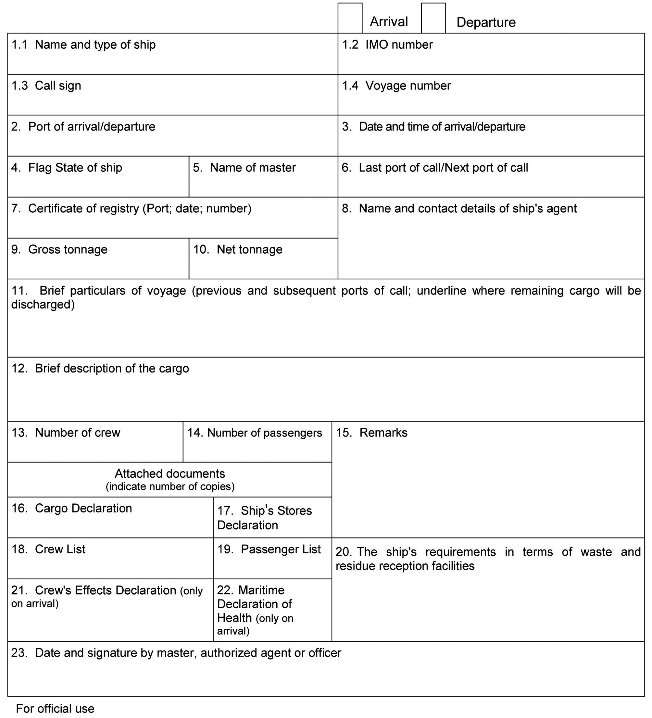

CARGO DECLARATION
(IMO FAL Form 2)
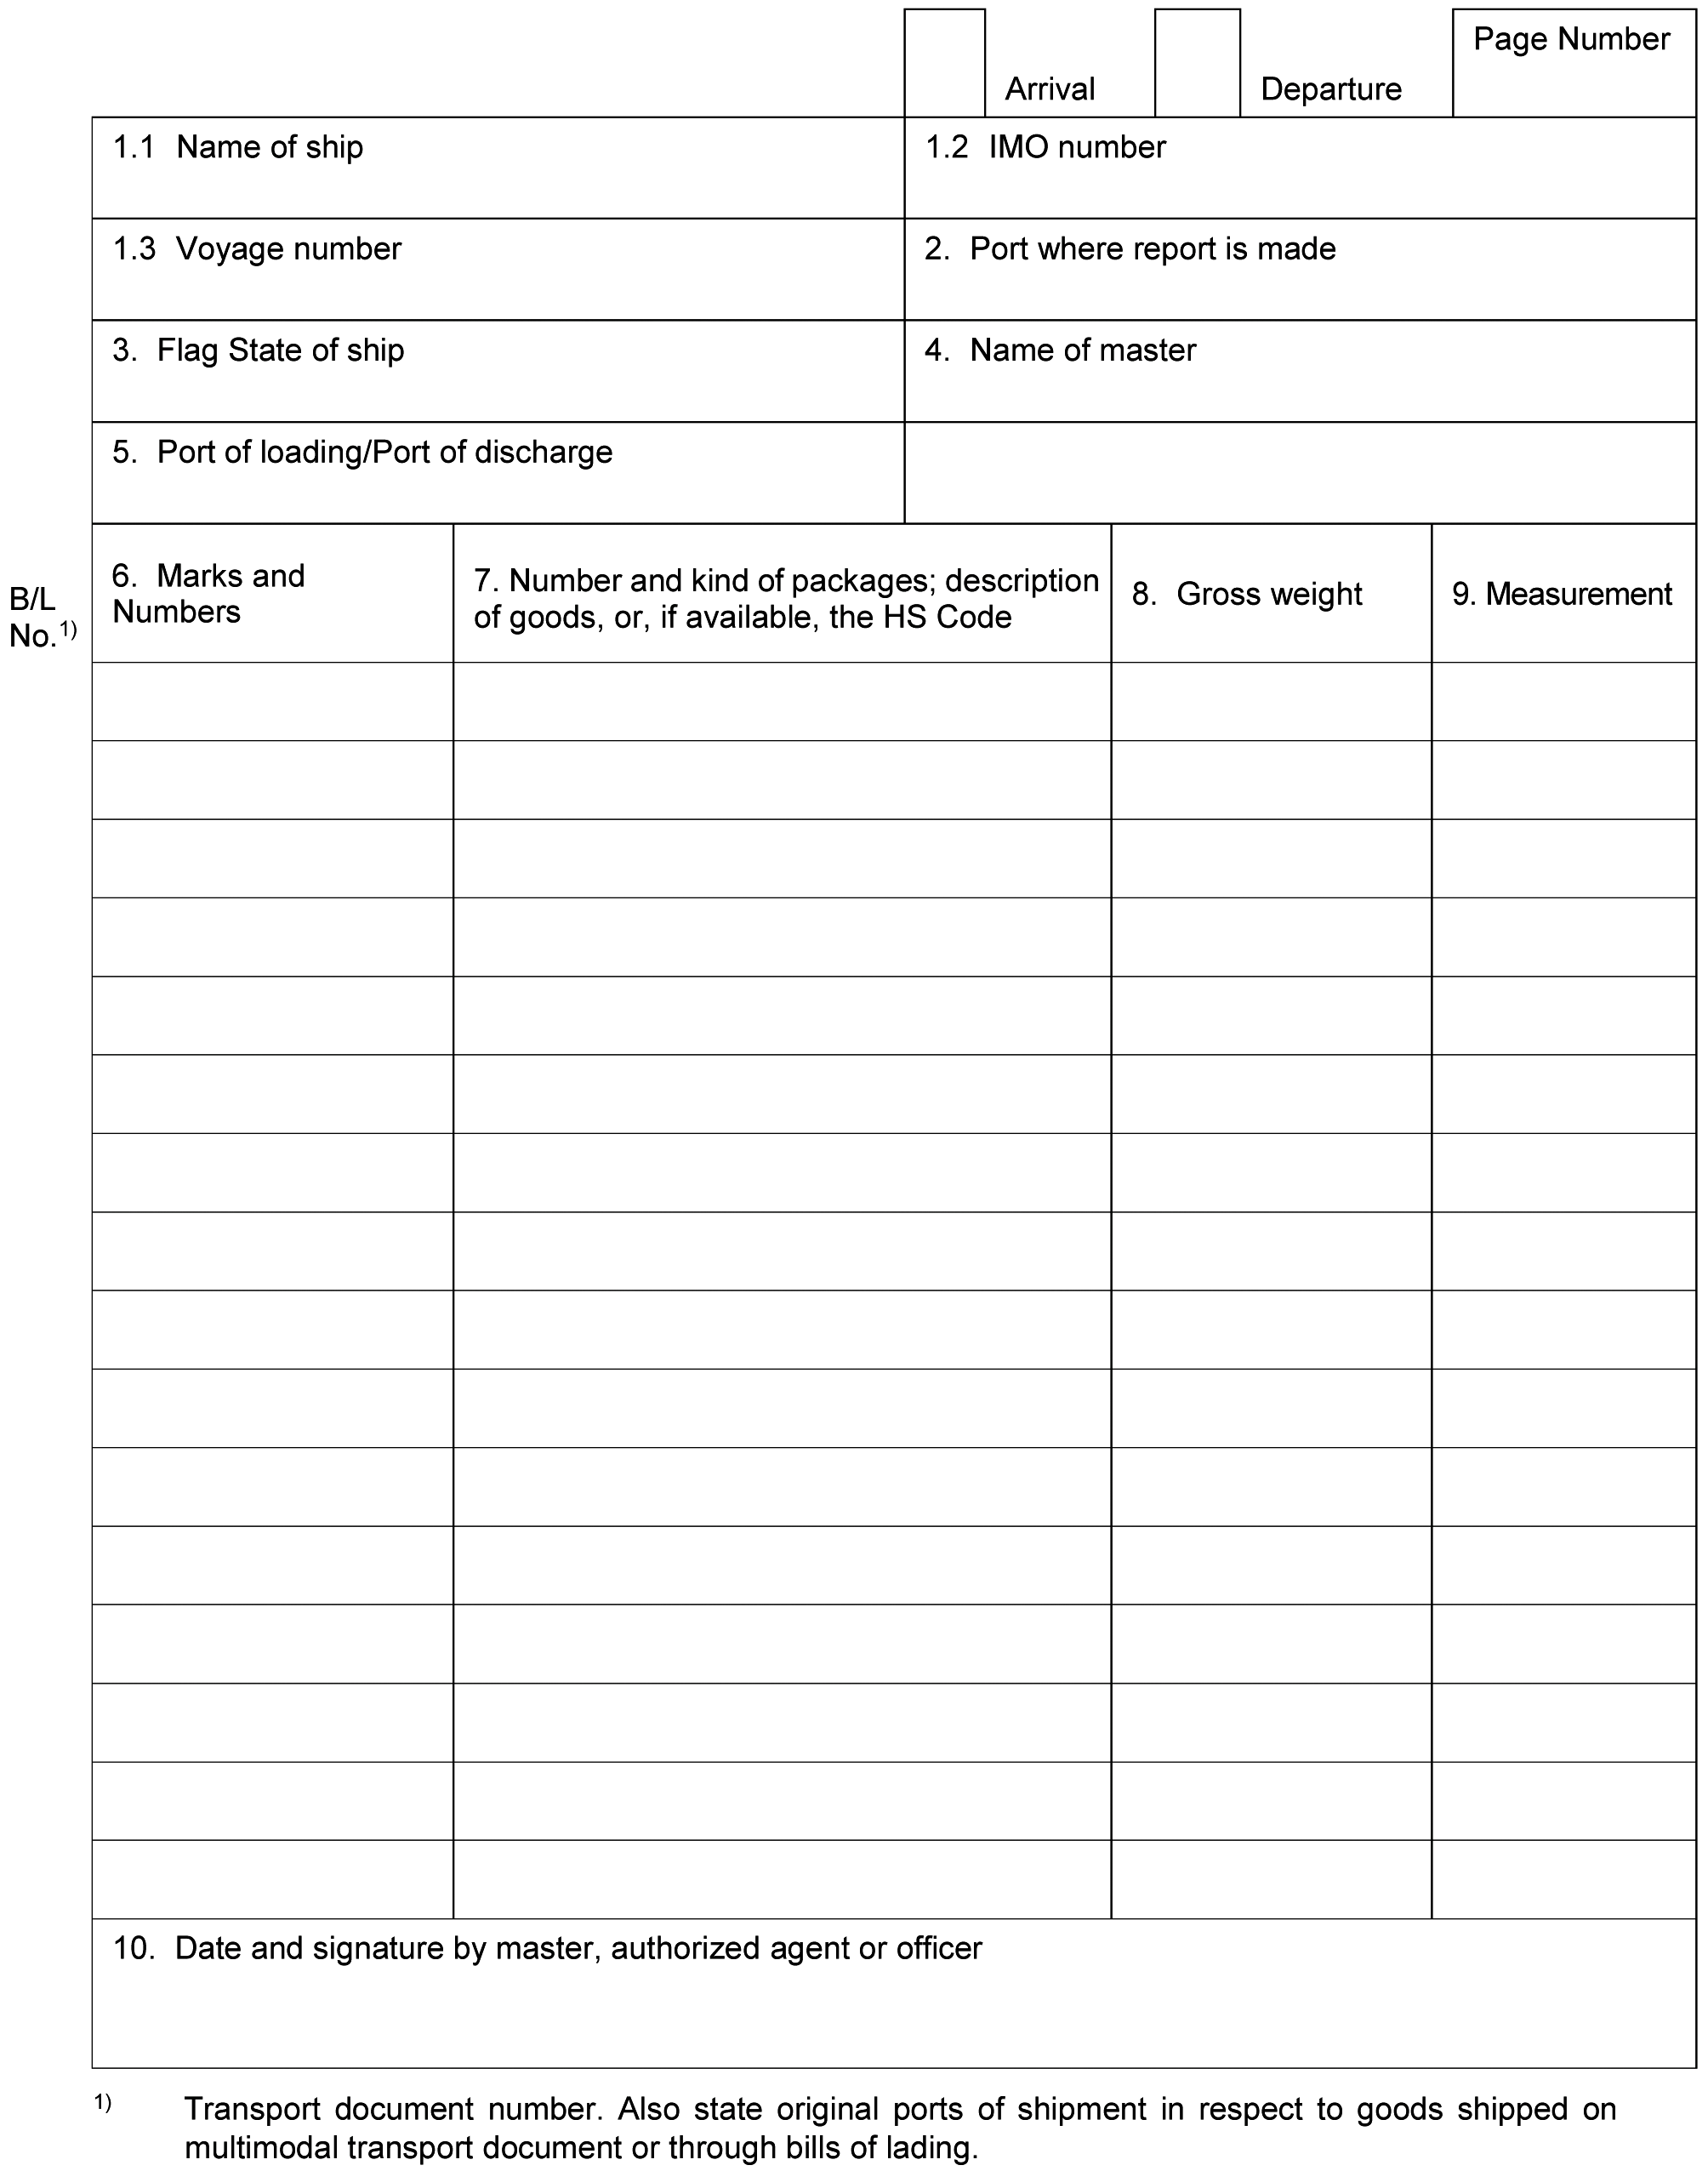

SHIP’S STORES DECLARATION
(IMO FAL Form 3)
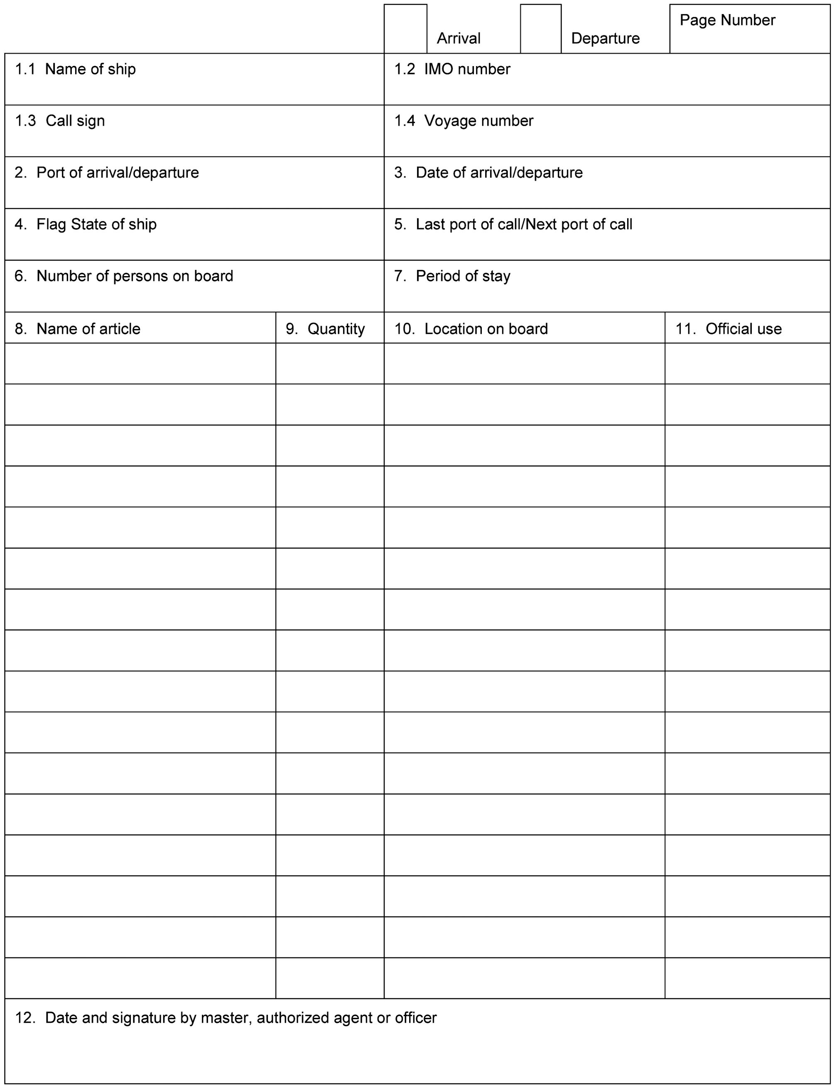

CREW’S EFFECTS DECLARATION
(IMO FAL Form 4)
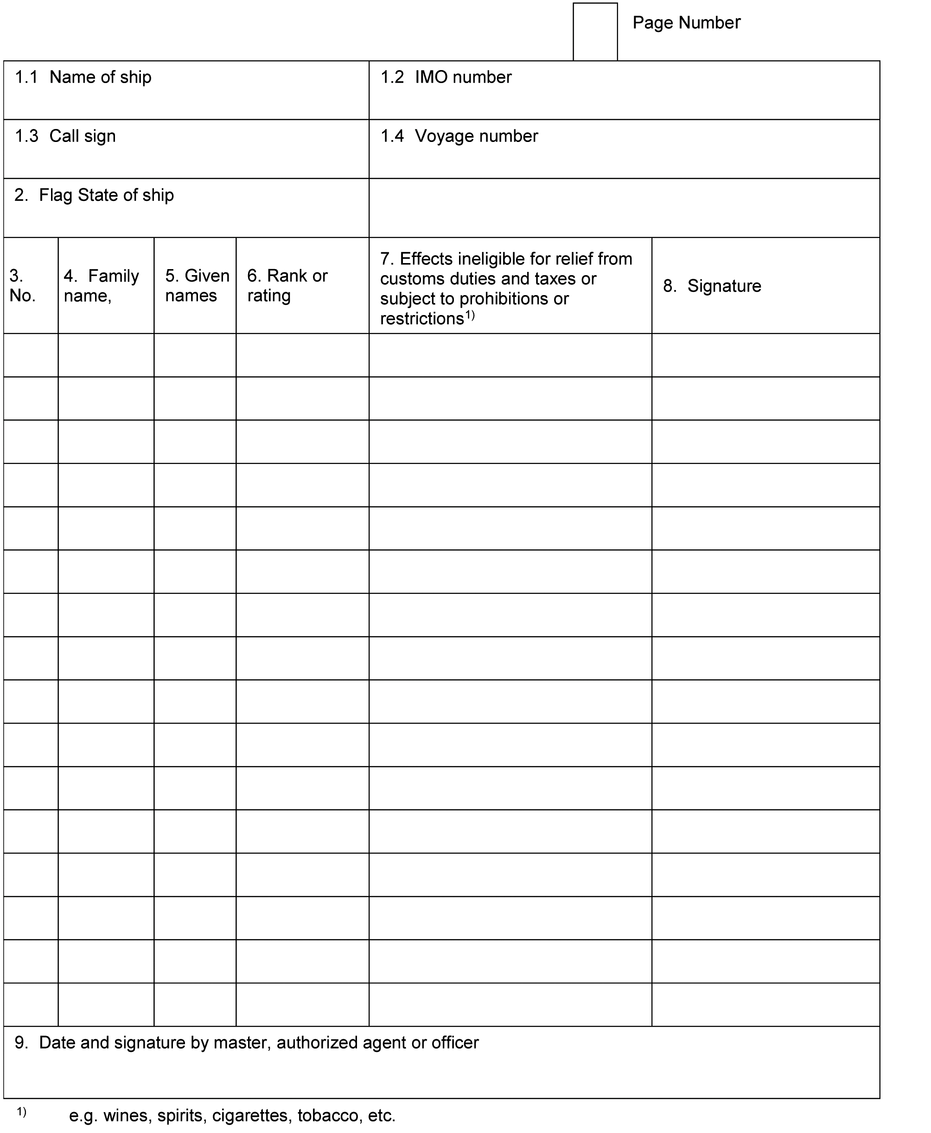

CREW LIST
(IMO FAL Form 5)
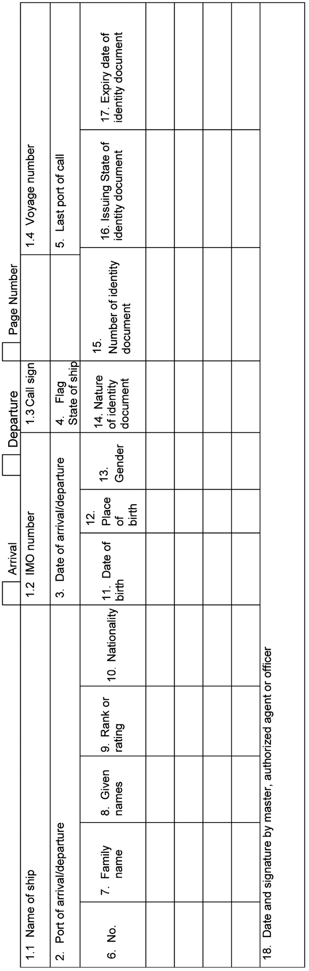

PASSENGER LIST
(IMO FAL Form 6)
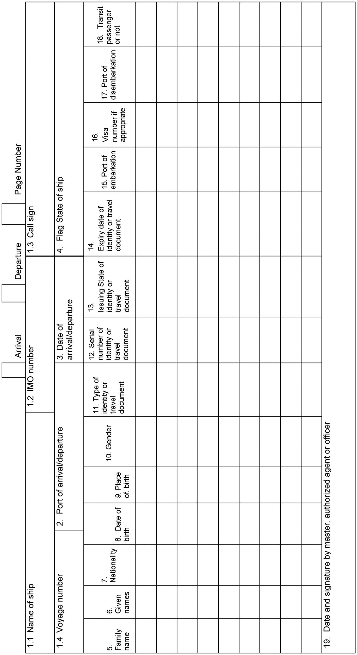

[DANGEROUS GOODS MANIFEST
(IMO FAL Form 7)
(As required by SOLAS 74, Chapter VII, regulation 4.5 and 7-2.2, MARPOL 73/78, Annex III, regulation 4.3 and chapter 5.4, paragraph 5.4.3.1 of the IMDG Code)
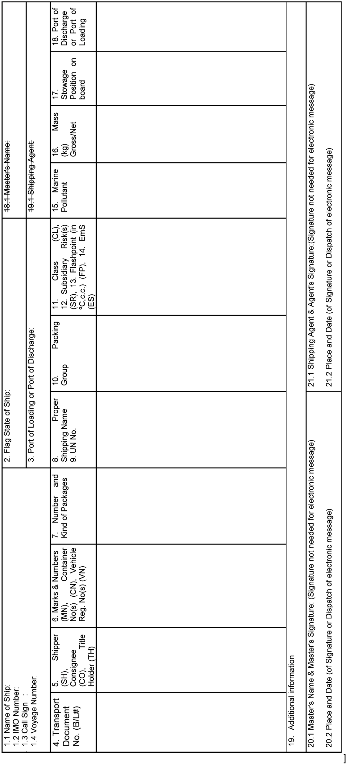

D. PARLEMENT
De wijzigingen van 8 april 2016 van de Bijlage bij het Verdrag behoeven ingevolge artikel 7, onderdeel f, van de Rijkswet goedkeuring en bekendmaking verdragen niet de goedkeuring van de Staten-Generaal.

G. INWERKINGTREDING
De wijzigingen van 8 april 2016 van de Bijlage bij het Verdrag zullen ingevolge artikel VII, tweede lid, onderdeel b, van het Verdrag voor alle partijen, waaronder het Koninkrijk der Nederlanden, in werking treden op 1 januari 2018, tenzij tenminste één derde van de verdragsluitende regeringen de Secretaris-Generaal vóór 1 oktober 2017 schriftelijk heeft medegedeeld de wijzigingen niet te aanvaarden.
Uitgegeven de achtentwintigste september 2016.
trb-2016-153
ISSN 0920 - 2218
's-Gravenhage 2016
De Minister van Buitenlandse Zaken,
A.G. KOENDERS

1) Het voor eensluidend gewaarmerkt afschrift is nog niet ontvangen. In de tekst kunnen derhalve onjuistheden voorkomen die in een volgend Tractatenblad zullen worden gecorrigeerd.
1) Reference is made to the Convention for the Suppression of Unlawful Acts against the Safety of Maritime Navigation, 1988 (SUA Convention), the International Ship and Port Facility Security Code (ISPS Code) and the International Convention for the Safety of Life at Sea, 1974 (SOLAS), chapter XI-2.
2) Since 1994 known as the World Customs Organization.
3) See FAL.2/Circ.127-MEPC.1/Circ.817-MSC.1/Circ.1462.
4) Convention on the Harmonized Commodity Description and Coding System: also known as the “Harmonized system” (HS). This international Convention came into force on 1 January 1988; its objective is to establish a description and coding system for use by customs administrations when designating commodities or commodity groups for the purposes of setting customs tariffs and collecting statistics.
5) A possible format for a covering letter is given in appendix 2.
6) Reference is made to Recommended Practice 11 and appendix II of Annex F3 of the Kyoto Convention.
7) In addition, public authorities may wish to consider the non-binding conclusion of the UNHCR Executive Committee on Stowaway Asylum-Seekers (1988, No. 53 (XXXIX)).

